Abstract:

Global market analysis is the process of examining and evaluating the performance of the world's financial markets. This involves collecting and analyzing data on economic indicators, market trends, and other factors that affect the behavior of financial markets. The main objective of global market analysis is to provide insights into the current state of the global economy and to help businesses and investors make informed decisions about their investments. The analysis of global markets is a complex task that requires the use of advanced statistical and analytical tools. The process involves collecting data on various economic indicators such as GDP, inflation, interest rates, and trade balances, as well as market data such as stock prices, commodity prices, and currency exchange rates. This data is then analyzed to identify trends and patterns that can help forecast future market behavior.

Global market analysis has become increasingly important in today's interconnected world economy. With the rise of globalization and the increasing interdependence of markets, businesses and investors need to have a clear understanding of the global economic landscape to make informed investment decisions. The analysis of global markets can help businesses and investors identify opportunities for growth, minimize risks, and optimize their investment strategies.

In conclusion, global market analysis plays a critical role in today's global economy. It provides valuable insights into the behavior of financial markets, and helps businesses and investors make informed decisions about their investments. With the increasing complexity of the global economic landscape, the need for accurate and insightful global market analysis has never been more important.

Procedure:

* Get the global market dataset: The first step is to obtain the global market dataset.
* Import the dataset into Power BI: Once we have the dataset, the next step is to import it into Power BI. We can do this by opening Power BI, clicking on "Get Data" in the home tab, and selecting the data source you are using. We have performed transform and cleaning of the data to make it usable in Power BI.
* Create visualizations: After importing the data, we start creating visualizations to analyze the data. We use the various visualizations available in Power BI, such as charts, graphs, and tables, to create meaningful visualizations that help us understand the data better.
* Analyze the data: Once we have created the visualizations, we start analyzing the data. We use the various features available in Power BI, such as filtering, sorting, and grouping, to analyze the data in different ways. We also create calculated columns and measures to perform more complex analysis.
* Share the results: Once we have completed the analysis, we shared the results by creating a dashboard.

Dashboard:

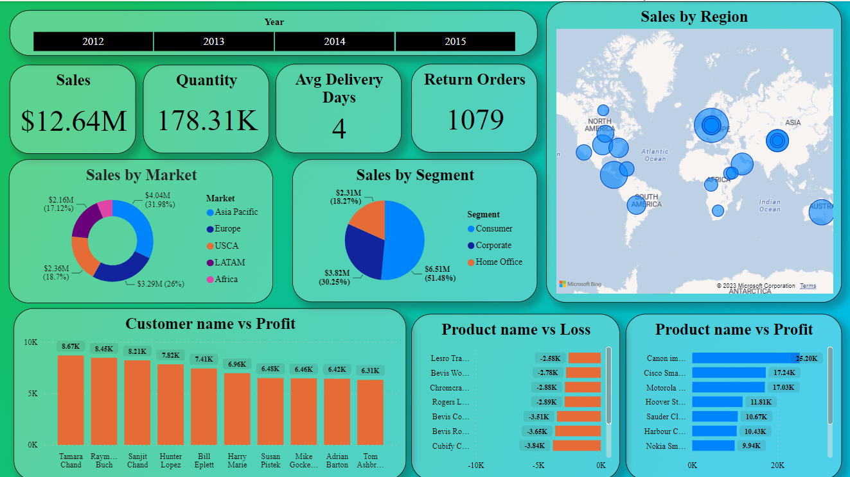

* The sales in the Asia-Pacific region are greater than in other markets.
* The maximum profit is obtained from the sales of cameras, phones, easy chairs, and bookshelves.
* The most significant sales come from individual consumers.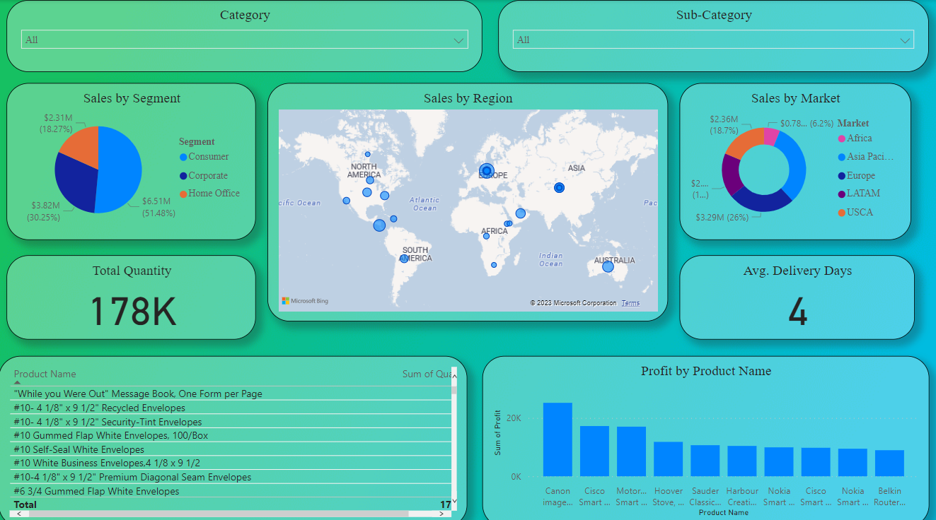This dashboard allows us to accurately determine the number of units sold for any individual product.

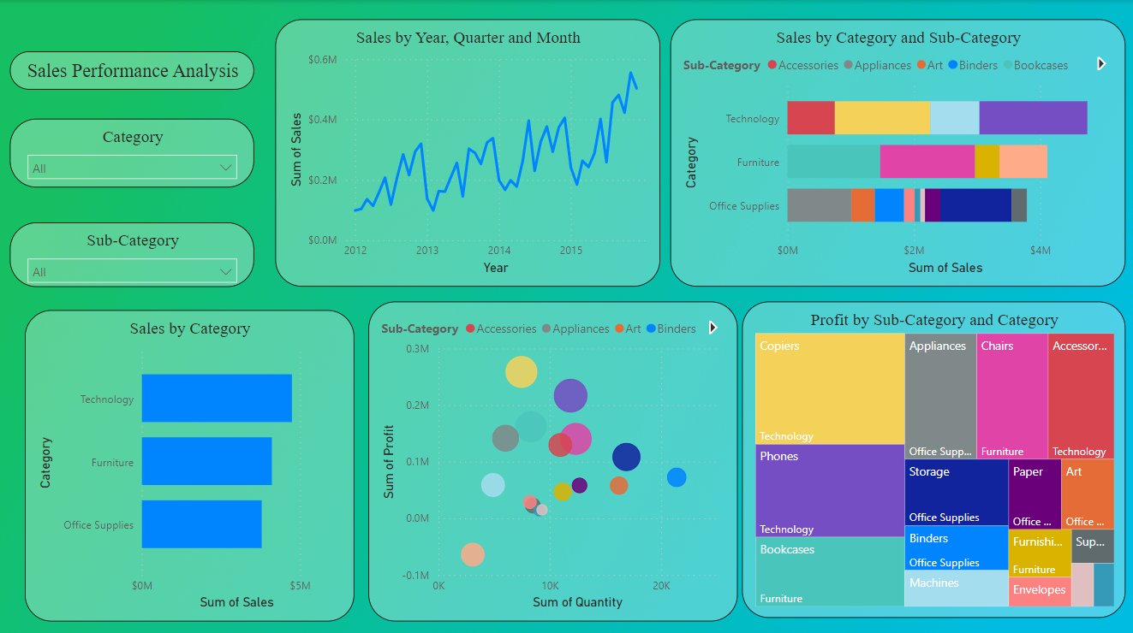

* This dashboard allows us to see that sales in the global market have experienced significant fluctuations over the years, and it shows signs of recovery in 2015.

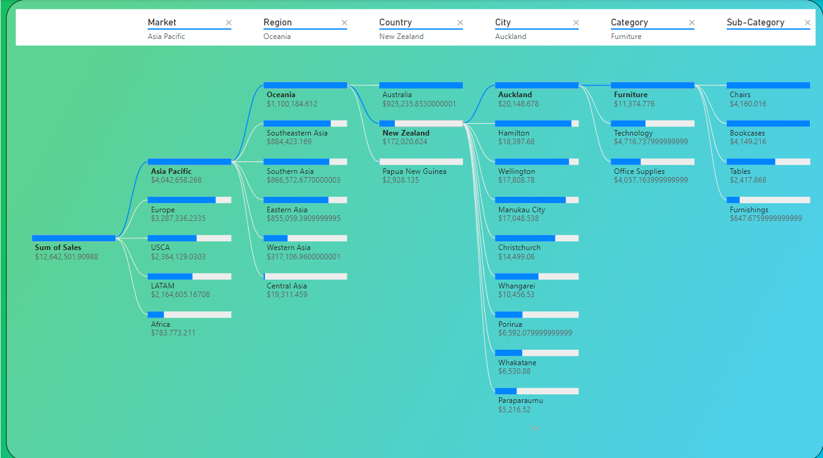

* This is a decomposition tree depicting the sales analysis.

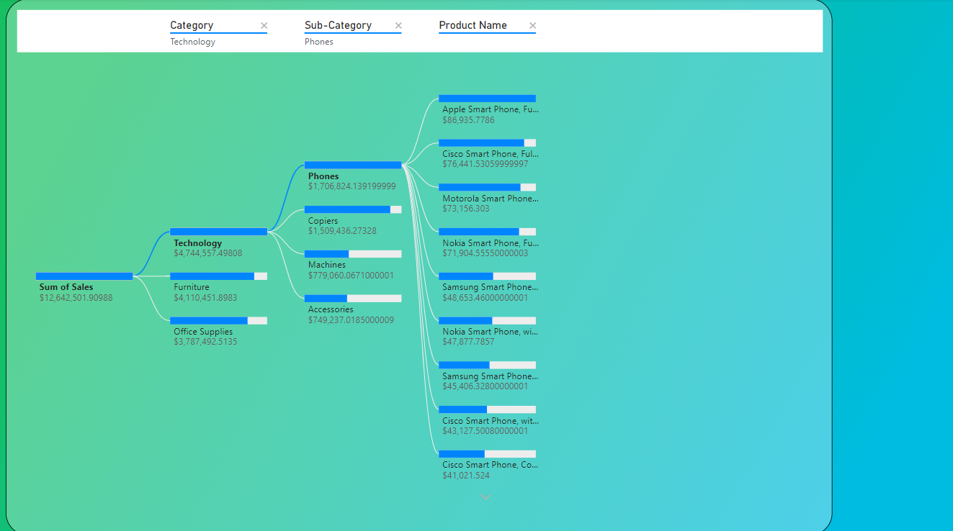

* This is a decomposition tree depicting the product analysis.

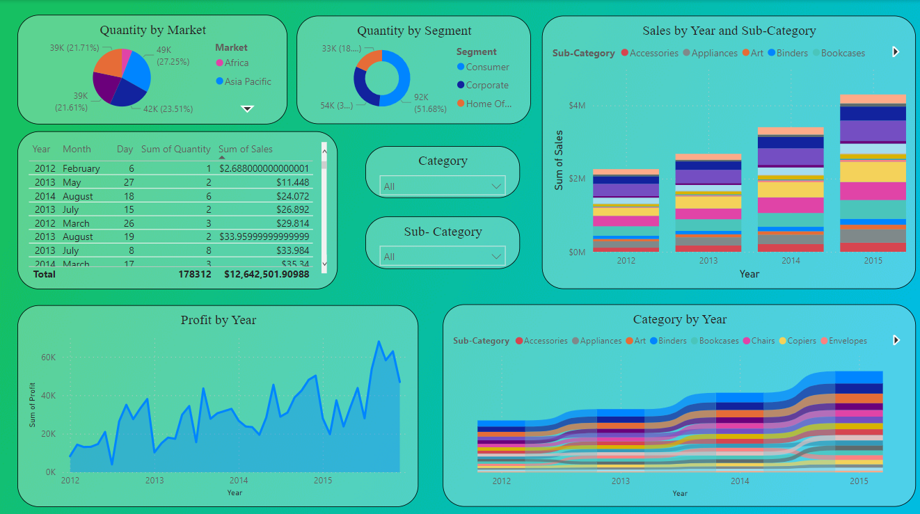

* This dashboard is a time series analysis in which we can infer that the sales has gradually improved over the years.

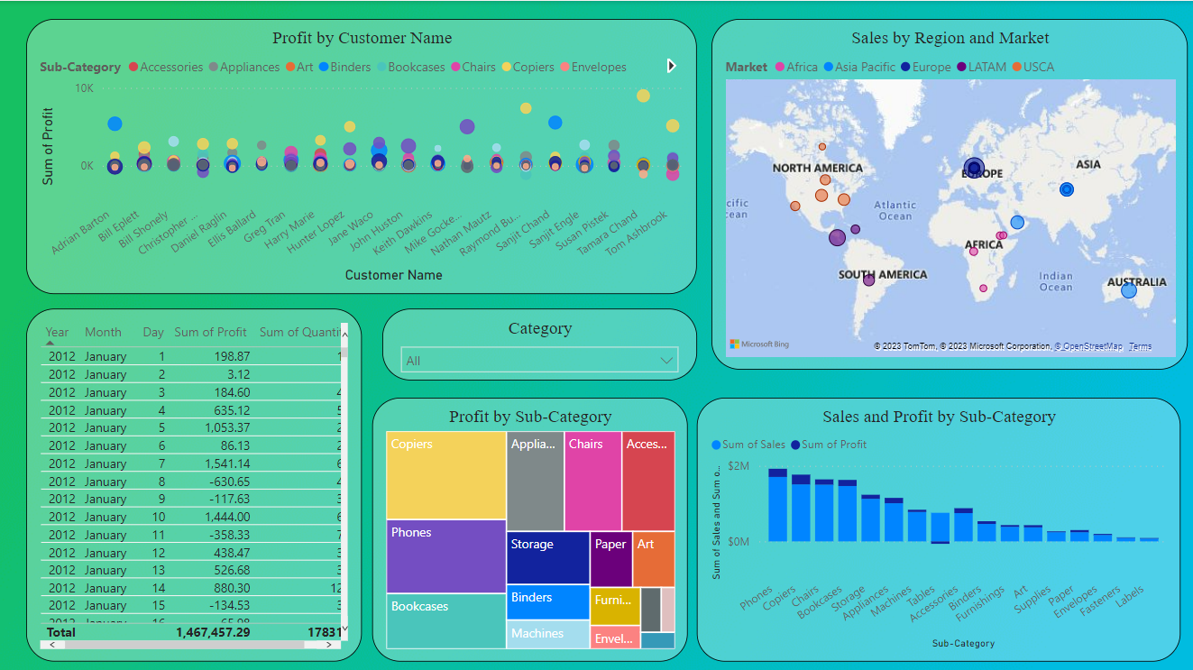

* This dashboard displays the profits earned by the top customers as well as the sales generated by different products.
* 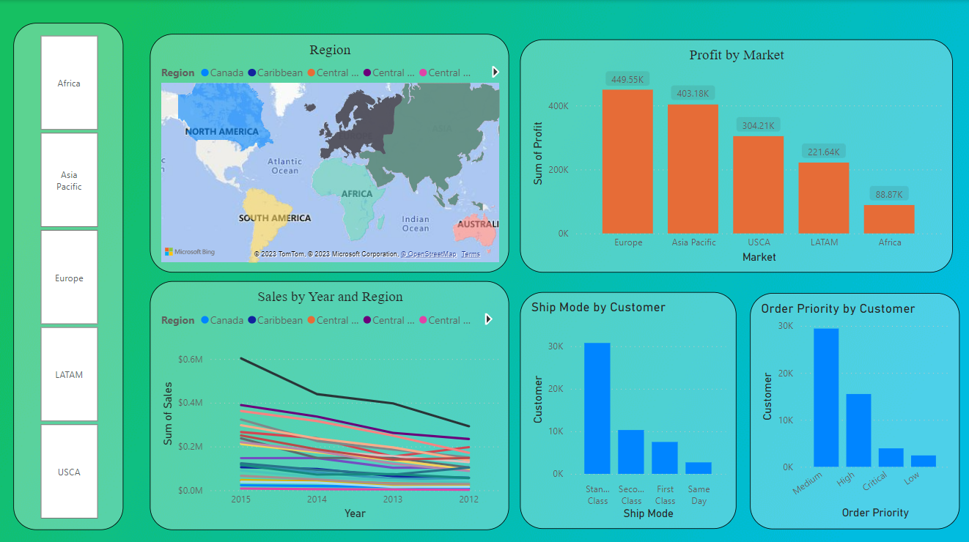The maximum profit was generated in Europe, followed by the Asia Pacific region.
* The majority of customers opt for standard class shipping instead of first class.
* And the order priority was medium rather than critical.

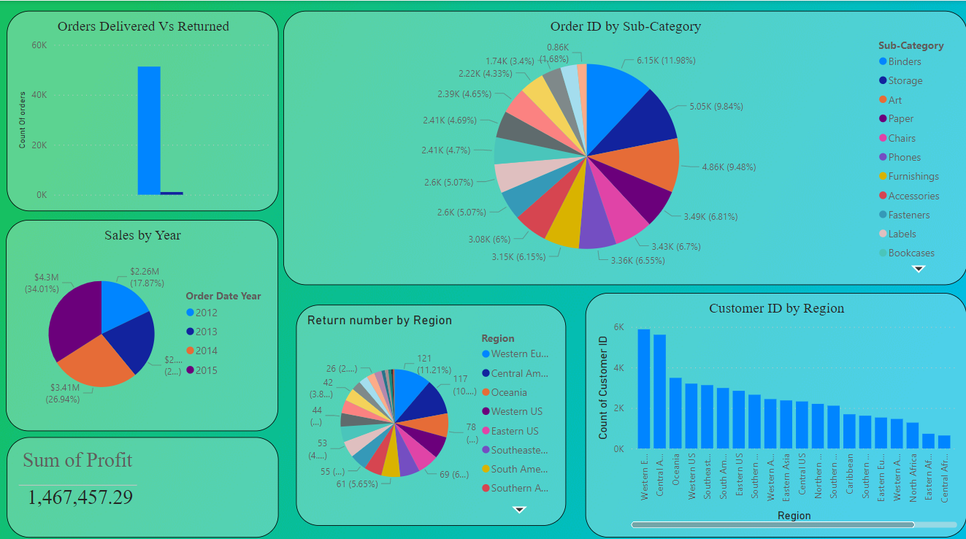

* The maximum number of product returns come from Western Europe.

Reasons why we should analyze global market:

* Understanding market trends: Analyzing the global market can help individuals and organizations understand market trends and patterns. This information can be used to make informed decisions about investments, business strategies, and more.
* Identifying growth opportunities: Analyzing the global market can help identify growth opportunities in various industries and markets. This information can be used to make strategic investments or expand business operations into new markets.
* Mitigating risks: Analyzing the global market can help identify potential risks and challenges, such as economic downturns or political instability, which could impact businesses and investments. By identifying these risks early on, individuals and organizations can take steps to mitigate them.
* Mitigating risks: Analyzing the global market can help identify potential risks and challenges, such as economic downturns or political instability, which could impact businesses and investments. By identifying these risks early on, individuals and organizations can take steps to mitigate them.
* Mitigating risks: Analyzing the global market can help identify potential risks and challenges, such as economic downturns or political instability, which could impact businesses and investments. By identifying these risks early on, individuals and organizations can take steps to mitigate them.